**GOOGLE TRANSLATOR/GOOGLE MAP/LANGUAGE:**

Being an International student, it is very difficult to find a location and moreover, in japan it is important to have a fluency in language for communication. If you are at Japan or if you are preparing to travel at Japan then there are few things that you need to know which might help in upcoming time:

**Purpose**: Multilingual translation service / Find location

**How does it Work:** Translate through image, text, voice which helps to translate easily.

**Download**: Google play, Playstore

[Google Translate - Apps on Google Play](https://play.google.com/store/apps/details?id=com.google.android.apps.translate&gl=US)

**iTranslate:**

**Download**: <https://itranslate.com>

Purpose: leading translation and dictionary app

*  iTranslate: This app enables travelers, students, business professionals, employers and medicals staff to read, write and speak in over 100 languages, anywhere in the world.

**Google Map:** For direction and is helpful to travel in public transportation

* To find location
* Buss/ train / Taxi stops
* Transportation departure and arrival time

**Residence Card/Hanko**

When you arrive in Japan with permission for a mid-term or a long term stay you will receive a Residence Card at the airport. All you need document are:

1. Passport
2. CoE
3. Vissa
4. Japan Vaccination Qr
5. Pledge Declaration

(Note: if you are entering in Japan as a Student then you need to put a stamp in your residence card of 28 hours work limit)

You must register your address at your city or ward office within 14 days of moving into a municipality. To register your address at your ward office documents you need to bring:

1. Passport
2. Residence Card

For hanko you need to search Don Quijote store near you that have vending machine, you need to input name in katagana or khanji so in that format hanko will be create.

The cost are varies from 500 to 10000 according to stamp design and attraction. It take 5 to 10 minute to create. Or you need to order online hanko from online site.

**Places to Visit in Kyoto**

1. Nijo Castle:

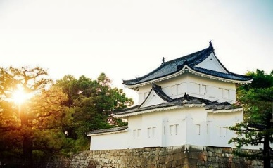

1. Fushimi-Inari Taisha Shrine

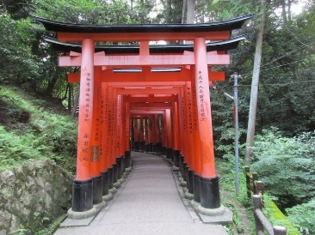

1. Kiyomize-dera Temple

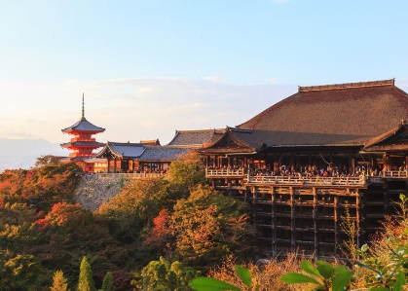

1. Kyoto Imperial Palace

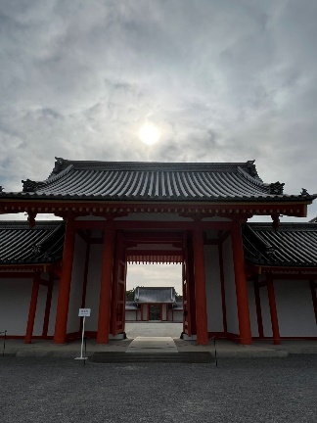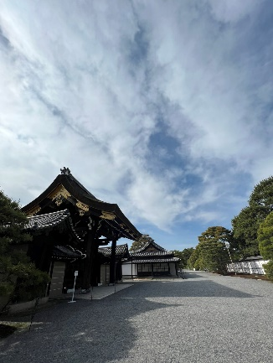

1. Gion’s Geishas and Temples

